

**EC540: Control System**

**A Report on**

**Problem statement Solution**

**By applying Routh-Hurwitz test, find how many roots of the polynomial a(s) =**

**4s^4 + 12s^3 + 25s^2 + 30s + 60 = 0 are left of -1. Show analytically and then verify**

**using MATLAB.**

**Submitted by**

|  |  |  |
| --- | --- | --- |
| **ROLL NO** | **NAME** | **USN** |
| **57** | **SUMANTHA ULLASA PRABHU** | **01JST18EC117** |

**Under the guidance of**

**SUDHARSHAN PATIL KULKARNI**

**AssistantProfessor**

**DEPARTMENT OF ELECTRONICS AND COMMUNICATION**

**SJCE MYSURU- 57000**

**THEORETICAL CALCULATION**

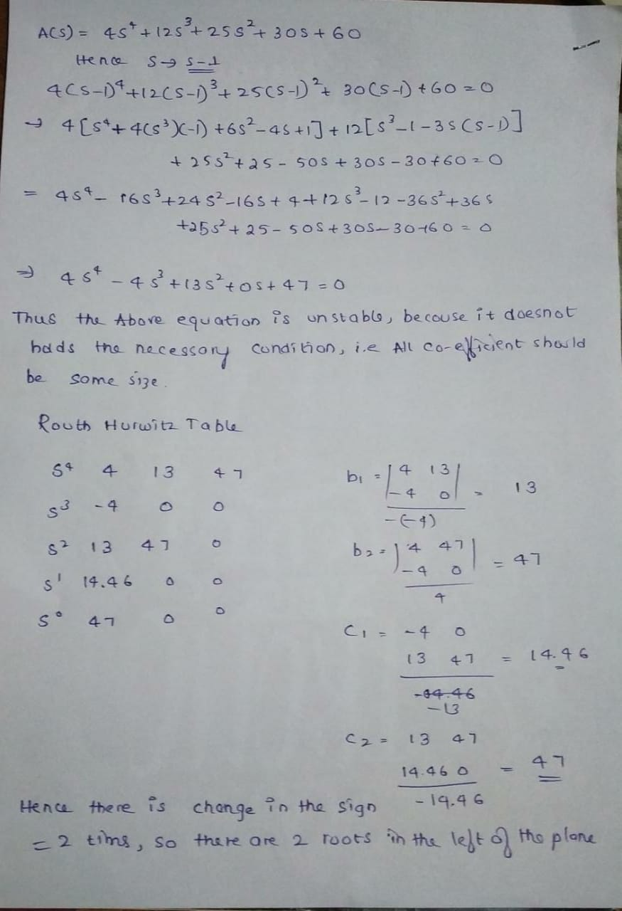

**MATLAB CODE AND PLOT**

% Initialization

clear ;

close all;

clc

coeffVector = input('input vector of your system coefficients: \n i.e. [an an-1 an-2 ... a0] = ');

ceoffLength = length(coeffVector);

rhTableColumn = round(ceoffLength/2);

rhTable = zeros(ceoffLength,rhTableColumn);

rhTable(1,:) = coeffVector(1,1:2:ceoffLength);

if (rem(ceoffLength,2) ~= 0)

% if odd, second row of table will be

rhTable(2,1:rhTableColumn - 1) = coeffVector(1,2:2:ceoffLength);

else

% if even, second row of table will be

rhTable(2,:) = coeffVector(1,2:2:ceoffLength);

end

epss = 0.01;

for i = 3:ceoffLength

if rhTable(i-1,:) == 0

order = (ceoffLength - i);

cnt1 = 0;

cnt2 = 1;

for j = 1:rhTableColumn - 1

rhTable(i-1,j) = (order - cnt1) * rhTable(i-2,cnt2);

cnt2 = cnt2 + 1;

cnt1 = cnt1 + 2;

end

end

for j = 1:rhTableColumn - 1

firstElemUpperRow = rhTable(i-1,1);

rhTable(i,j) = ((rhTable(i-1,1) * rhTable(i-2,j+1)) - ....

(rhTable(i-2,1) * rhTable(i-1,j+1))) / firstElemUpperRow;

end

% special case: zero in the first column

if rhTable(i,1) == 0

rhTable(i,1) = epss;

end

end

% Initialize unstable poles with zero

unstablePoles = 0;

% Check change in signs

for i = 1:ceoffLength - 1

if sign(rhTable(i,1)) * sign(rhTable(i+1,1)) == -1

unstablePoles = unstablePoles + 1;

end

end

% Print calculated data on screen

fprintf('\n Routh-Hurwitz Table:\n')

rhTable

% Print the stability result on screen

if unstablePoles == 0

fprintf('it is a stable system!\n')

else

fprintf('it is an unstable system!\n')

end

fprintf('\n Number of right hand side poles =%2.0f\n',unstablePoles)

reply = input('Do you want roots of system be shown? Y/N ', 's');

if reply == 'y' || reply == 'Y'

sysRoots = roots(coeffVector);

fprintf('\n Given polynomial coefficients roots :\n')

sysRoots

end

**OUTPUT AND PLOTS:**

input vector of your system coefficients:

i.e. [an an-1 an-2 ... a0] =

[4 -4 13 0 47]

Routh-Hurwitz Table:

rhTable =

4.0000 13.0000 47.0000

-4.0000 0 0

13.0000 47.0000 0

14.4615 0 0

47.0000 0 0

it is an unstable system!

Number of right hand side poles = 2

Do you want roots of system be shown? Y/N

y

Given polynomial coefficients roots :

sysRoots =

1.2595 + 1.6817i

1.2595 - 1.6817i

-0.7595 + 1.4440i

-0.7595 - 1.4440i

G = tf([4 -4 13 0 47],[1])

pzmap(G)

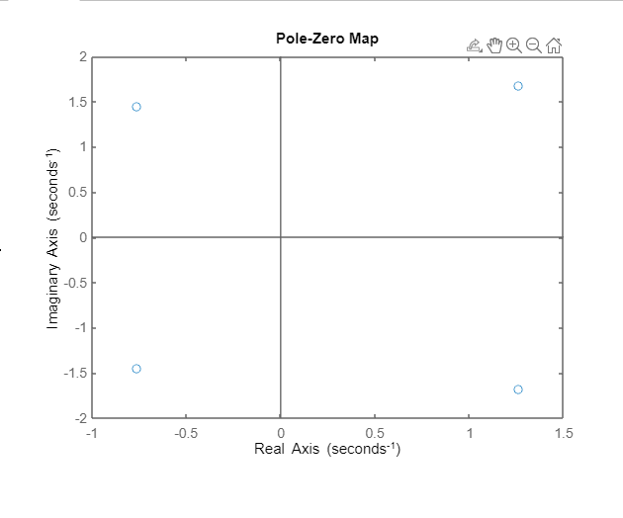

If we use the given equation, then in the pzmap there is shift in the imaginary axis but roots remain the same.

G1 = tf([4 12 25 30 60],[1])

pzmap(G1)

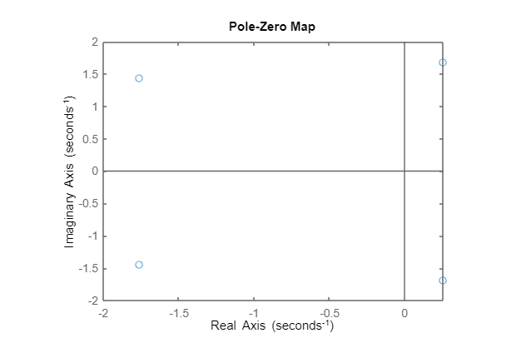

CONCLUSION:

As we have seen that in the A(s) equation the necessary condition is not satisfied, i.e all the coefficients of the equation should be in the same size. Even though it's not a sufficient condition we did the Routh herwitz test in which all the poles(roots ) are present in the right of the plane s = -1.

Thus we can conclude that the system is unstable when the s = -1.and 4 roots are present at the right of the plane s = -1.

Thank you